**Task Description**

The task includes -

* Creating AWS S3 Bucket
* Uploading Website files
* Hosting static website in S3
* Testing in browser

About **AWS S3 Bucket :**

1. AWS **S3 (Simple Storage Service)** is a fully managed object storage service offered by Amazon Web Services.

2. It is used for storing and retrieving any amount of data from anywhere in the world.

3. S3 is **highly scalable** and can store any type of data, including text, images, video, and audio.

4. S3 is **highly secure and provides comprehensive encryption**, data integrity, and access control capabilities.

5. S3 **supports versioning**, allowing users to keep multiple versions of the same object.

6. S3 has a **variety of storage classes**, including Standard, Infrequent Access, Glacier, and Glacier Deep Archive.

7. S3 supports a range of APIs, including REST, SOAP, and BitTorrent.

8. S3 also provides built-in analytics and reporting capabilities to track and analyze usage.

9. S3 is integrated with AWS services such as CloudFront, CloudWatch, and AWS Lambda.

10. S3 is **cost-effective,** with storage and data transfer costs dependent on the type of storage class and data transfer rates.

**Screenshots of the tasks :**

* Creating AWS S3 bucket and uploading all website files into bucket

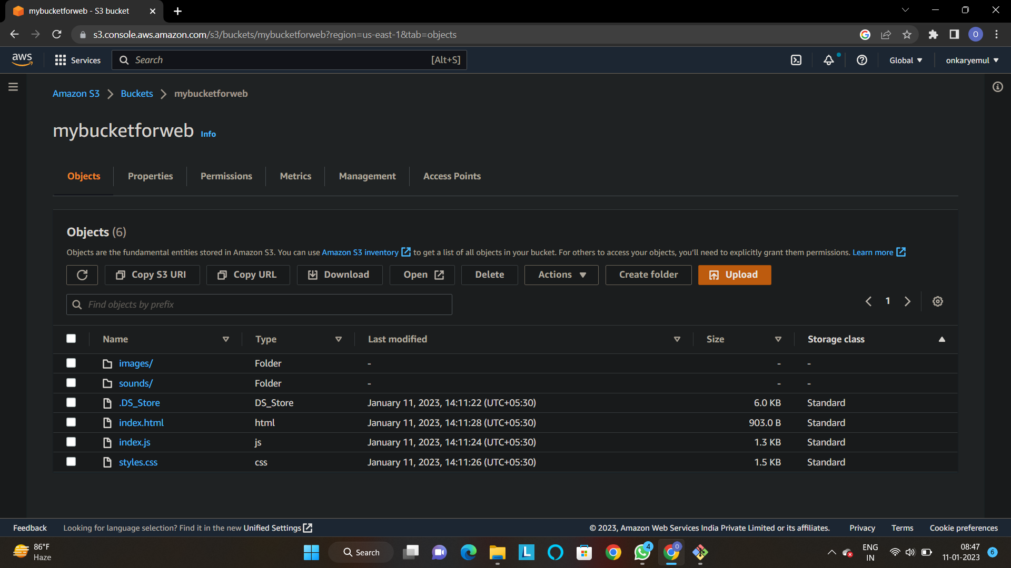

Successfully created AWS S3 bucket and uploaded files into it.

* Enable Static Website Hosting

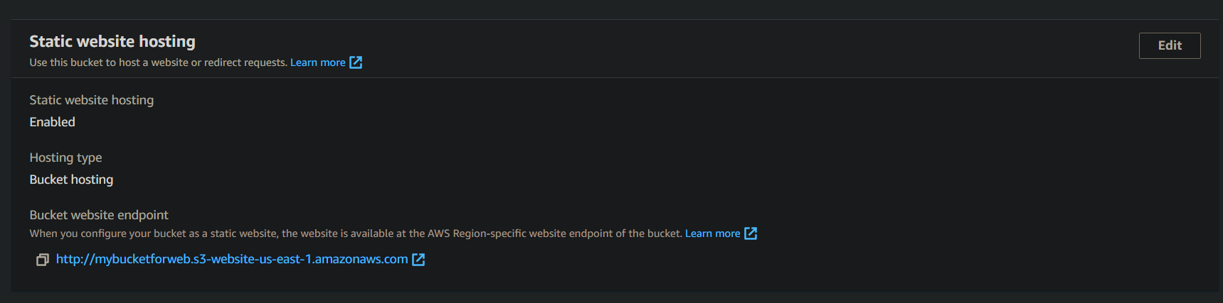

Successfully enabled static website hosting.

* Grant all public access to the S3 bucket

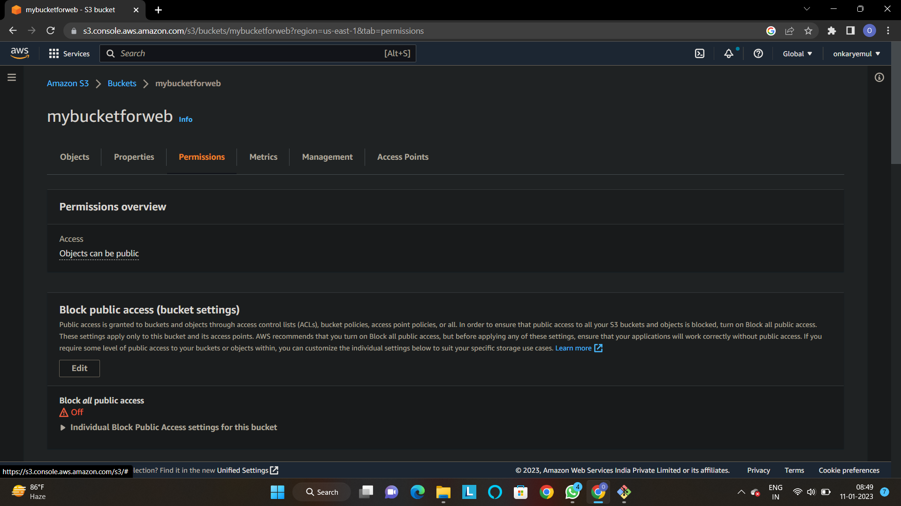

* Make all objects in the bucket as public

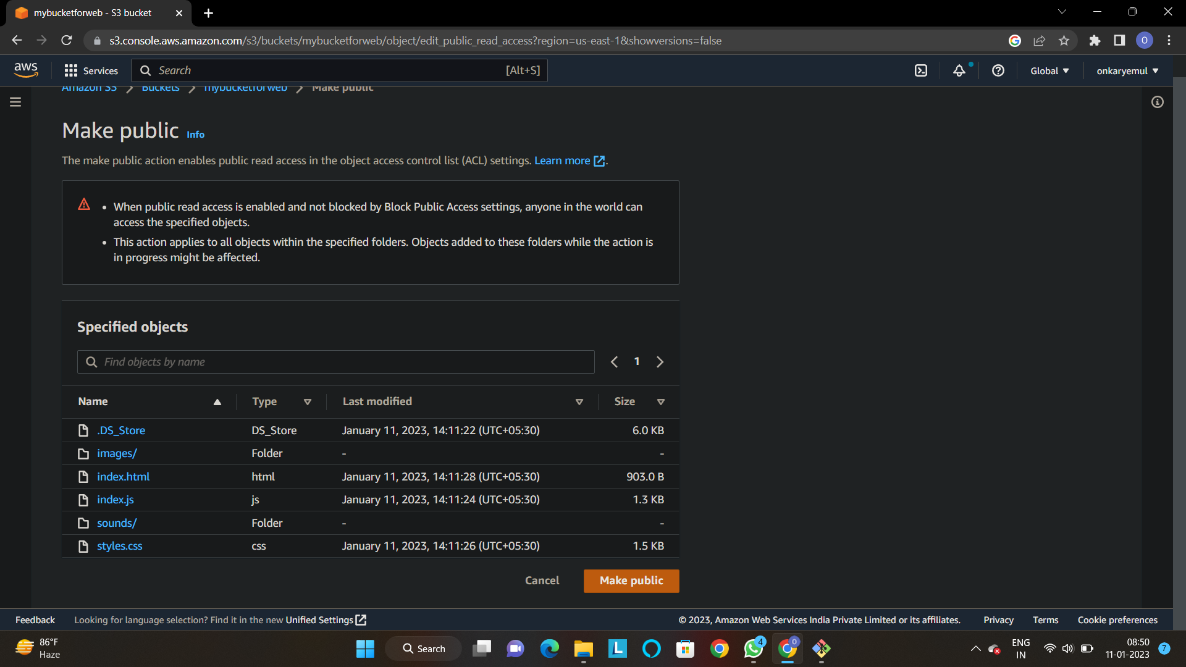

* Finally copy URL of the static website endpoint and paste it in the new tab

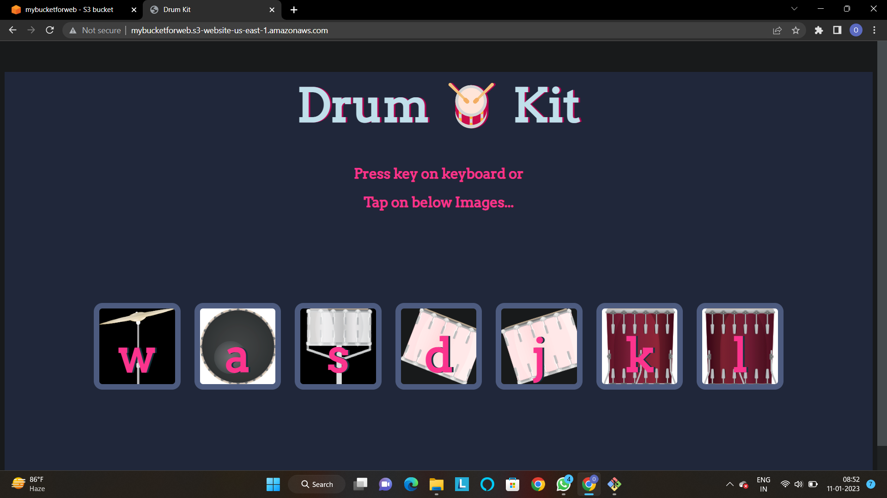

Successfully completed the task!

**Here’s IP of my task**

<http://mybucketforweb.s3-website-us-east-1.amazonaws.com/>

THANK YOU!!